***JAVA PROJECT***

***Problem statement***

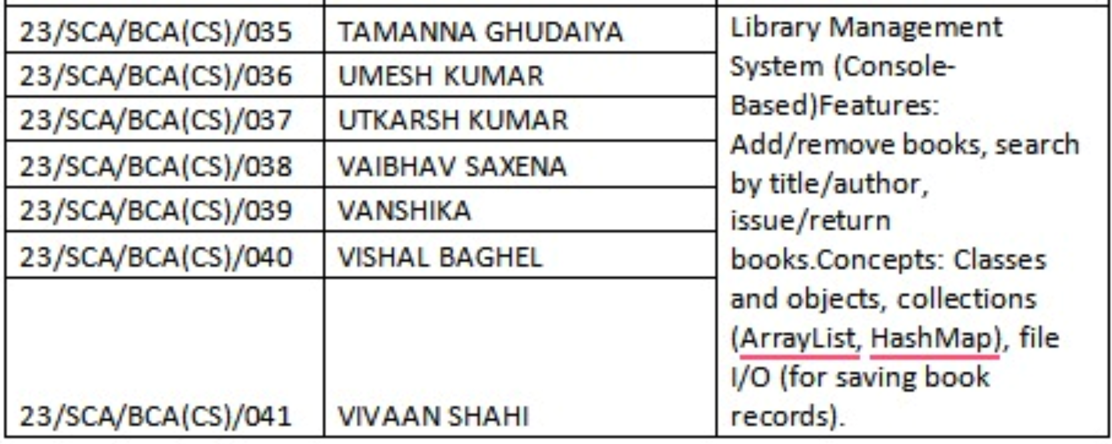

Solution -

import java.util.*;  
import java.io.*;  
  
public class Main {  
 static class Book implements Serializable {  
 private String title;  
 private String author;  
 private boolean isIssued;  
  
 public Book(String title, String author) {  
 this.title = title;  
 this.author = author;  
 this.isIssued = false;  
 }  
  
 public String getTitle() { return title; }  
 public String getAuthor() { return author; }  
 public boolean isIssued() { return isIssued; }  
 public void issue() { isIssued = true; }  
 public void returnBook() { isIssued = false; }  
  
 public String toString() {  
 return title + " by " + author + (isIssued ? " [Issued]" : " [Available]");  
 }  
 }  
  
 static class Library {  
 private ArrayList<Book> books;  
 private final String fileName = "library.dat";  
  
 public Library() {  
 books = loadBooks();  
 }  
  
 public void addBook(Book book) {  
 books.add(book);  
 saveBooks();  
 }  
  
 public void removeBook(String title) {  
 books.removeIf(book -> book.getTitle().equalsIgnoreCase(title));  
 saveBooks();  
 }  
  
 public void search(String keyword) {  
 for (Book book : books) {  
 if (book.getTitle().toLowerCase().contains(keyword.toLowerCase()) ||  
 book.getAuthor().toLowerCase().contains(keyword.toLowerCase())) {  
 System.*out*.println(book);  
 }  
 }  
 }  
  
 public void issueBook(String title) {  
 for (Book book : books) {  
 if (book.getTitle().equalsIgnoreCase(title) && !book.isIssued()) {  
 book.issue();  
 System.*out*.println("Book issued: " + title);  
 saveBooks();  
 return;  
 }  
 }  
 System.*out*.println("Book not found or already issued.");  
 }  
  
 public void returnBook(String title) {  
 for (Book book : books) {  
 if (book.getTitle().equalsIgnoreCase(title) && book.isIssued()) {  
 book.returnBook();  
 System.*out*.println("Book returned: " + title);  
 saveBooks();  
 return;  
 }  
 }  
 System.*out*.println("Book not found or not issued.");  
 }  
  
 public void showAllBooks() {  
 for (Book book : books) {  
 System.*out*.println(book);  
 }  
 }  
  
 private void saveBooks() {  
 try (ObjectOutputStream out = new ObjectOutputStream(new FileOutputStream(fileName))) {  
 out.writeObject(books);  
 } catch (IOException e) {  
 System.*out*.println("Error saving books.");  
 }  
 }  
  
 private ArrayList<Book> loadBooks() {  
 try (ObjectInputStream in = new ObjectInputStream(new FileInputStream(fileName))) {  
 return (ArrayList<Book>) in.readObject();  
 } catch (IOException | ClassNotFoundException e) {  
 return new ArrayList<>();  
 }  
 }  
 }  
  
 public static void main(String[] args) {  
 Library lib = new Library();  
 Scanner sc = new Scanner(System.*in*);  
 int choice;  
  
 do {  
 System.*out*.println("\n--- Library Management System ---");  
 System.*out*.println("1. Add Book");  
 System.*out*.println("2. Remove Book");  
 System.*out*.println("3. Search Book");  
 System.*out*.println("4. Issue Book");  
 System.*out*.println("5. Return Book");  
 System.*out*.println("6. Show All Books");  
 System.*out*.println("0. Exit");  
 System.*out*.print("Enter your choice: ");  
 choice = sc.nextInt();  
 sc.nextLine(); // consume newline  
  
 switch (choice) {  
 case 1:  
 System.*out*.print("Title: ");  
 String title = sc.nextLine();  
 System.*out*.print("Author: ");  
 String author = sc.nextLine();  
 lib.addBook(new Book(title, author));  
 break;  
 case 2:  
 System.*out*.print("Title to remove: ");  
 lib.removeBook(sc.nextLine());  
 break;  
 case 3:  
 System.*out*.print("Search keyword: ");  
 lib.search(sc.nextLine());  
 break;  
 case 4:  
 System.*out*.print("Title to issue: ");  
 lib.issueBook(sc.nextLine());  
 break;  
 case 5:  
 System.*out*.print("Title to return: ");  
 lib.returnBook(sc.nextLine());  
 break;  
 case 6:  
 lib.showAllBooks();  
 break;  
 case 0:  
 System.*out*.println("Exiting...");  
 break;  
 default:  
 System.*out*.println("Invalid choice.");  
 }  
 } while (choice != 0);  
  
 sc.close();  
 }  
}

Ppt link-

https://www.canva.com/design/DAGmiwsEYpg/GYtYfPbd0_68-FEK0CLCPw/edit?utm_content=DAGmiwsEYpg&utm_campaign=designshare&utm_medium=link2&utm_source=sharebutton